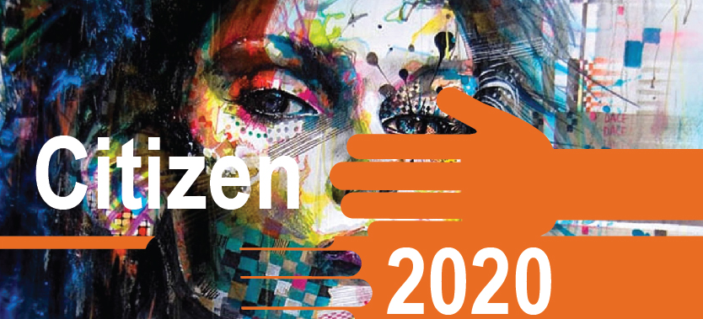 | We are very pleased to launch the Citizen 2020 II project at the North Acton Spring Community Day with Near Neighbours support. C2020II addresses the need for a more proactive, creative and effective initiative in supporting understanding, integration and participation of diverse communities through:  - Qualitative accredited training will explore identity,  - Discuss, envision, create art work and expressions that empower,  - Share this experience and personal journey through exhibition.  Sessions start Wednesday 30th May from 6-8pm at North Acton Pavilion with our experienced team. We will build to an exhibition of work and sharing of stories that will be launched at the North Acton Summer Community Day on Sunday 15th July.

If you are interested in finding out more and joining us for a reflective and creative journey, email rachel@artification.org.uk or sign up here:
Name | Contact details

