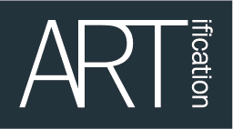

North Acton Pavilion Community Day 2018
Saturday 15th December
11am – 3pm
APPLICATION FORM

Name:

Website (if you have one):

Contact name:

Address:

Telephone no:

Email:

What type of performance will you be doing?

Number of performers?
(Include singer, percussion, dancers etc)

Do you have Public Liability Insurance?

Please indicate how you would like to be introduced by the MC on the day:

How long will your performance last (approx)?

Any other comments:

Don’t forget to complete this form and return it to us on Friday 7th December

