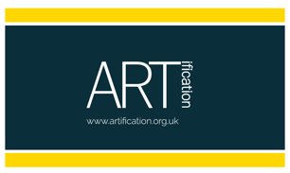
You choose!
Help choose the theme & content for the Bollo Brook Park mural. We are asking for your creative input & ideas for a mural in the new park. What kind of art reflects the South Acton community / local heritage / the new park environment? What message should the art represent? Please tell us your ideas for the mural.
What images inspire you & would you like to see in the mural?

Are there any stories, topics, themes that you’d like portrayed?

What style, content, colour scheme would you like to see?

List 3 key words to stimulate the best artwork for the park site:
- _
- _
- _

Established in 2003, ARTification is an Acton Charity that celebrates art, culture, community through projects, events & experiences. We have brought murals to Acton since 2005. Be a part of the latest one planned for 2020. See www.artification.org.uk or email info@artification.org.uk
The wall; The park; Past & 2019 ARTification Murals
